

**TECHNICAL MANUAL**

rectangle

Firewall Setup   
Windows 2022 AD Server

**Prepared By :** Giuseppe Raciti **Prepared on :** 23/06/2023

**Table of Contents**

**Introduction 3**

Purpose and Scope 3

Overview of pfSense 3

Key Features 3

Prerequisites 3

Document Structure 3

Document Revision History 3

**System Architecture 4**

Overview 4

**Installation 5**

Pre-installation Requirements 5

Virtual Switch Installation Steps 5

Create a switch for the WAN networks: 6

Modify the virtual machine settings for pfSense 9

**Installation (Cont) 11**

**Post Installation VM Configuration 13**

**First Boot and Configuration 14**

**Accessing the GUI 16**

**User Management 18**

User Roles and Permissions 18

Creating and Managing User Accounts 18

Defining and Assigning Roles and Capabilities 18

Authentication Options 18

**Data Ingestion 19**

Data Input Options 19

Configuring and Managing Data Inputs 19

Setting Up Source types and Automatic Field Extraction 19

Managing Data Input Pipelines and Source types 19

**Search and Analysis 20**

**Data Management 21**

**Security and Access Control 22**

**Monitoring and Troubleshooting 23**

**Maintenance and Upgrades 24**

**Best Practices 25**

**Resources and References 26**

| Introduction |
| --- |
| Purpose and Scope The purpose of this document is to introduce pfSense, an open-source firewall and routing platform. It aims to familiarise users with the features, capabilities, and benefits of pfSense in securing and managing network traffic. Overview of pfSense pfSense is a free and open-source firewall and routing software based on the FreeBSD operating system. It provides a robust set of features that make it suitable for a wide range of network deployments, including small to large enterprise networks, home offices, and educational institutions. Key Features  * **Firewall**: pfSense offers advanced firewall capabilities, allowing administrators to define and enforce firewall rules to control incoming and outgoing network traffic. * **Routing:** pfSense acts as a powerful router, providing support for various routing protocols, such as OSPF and BGP, as well as static and dynamic routing. * **VPN Connectivity:** pfSense supports multiple VPN protocols, including IPsec, OpenVPN, and PPTP, enabling secure remote access and site-to-site connectivity. * **Intrusion Detection and Prevention:** It includes intrusion detection and prevention system (IDS/IPS) functionality to safeguard against network attacks and malicious activities. * **Quality of Service (QoS):** pfSense allows administrators to prioritise network traffic, ensuring critical applications receive the necessary bandwidth and minimising latency. * **Web Filtering and Proxy:** It offers web filtering capabilities to restrict or control access to specific websites or categories, as well as transparent proxy services. * **High Availability:** pfSense supports high availability configurations, allowing for failover and redundancy in critical network environments. * **Captive Portal:** It provides captive portal functionality for guest or public Wi-Fi networks, enabling user authentication and access control  Prerequisites To make the most of pfSense, familiarity with TCP/IP networking, routing concepts, and firewall principles is beneficial. Basic knowledge of Linux or BSD-based operating systems is also helpful, although not mandatory. Access to a physical or virtual machine on which pfSense can be installed is required to follow practical configurations and exercises. Document Structure The document is organized into several sections, each focusing on specific aspects of pfSense. It starts with an overview of installation and initial configuration, followed by detailed explanations of firewall rules, routing, VPN setup, and additional advanced features. It concludes with best practices and references for further learning. Document Revision History Version 1.0 (June 2023): Initial release of the pfSense introduction document. |

| System Architecture |
| --- |
| Overview The pfSense system architecture is designed to provide a flexible and scalable solution for network security and routing. It consists of multiple components that work together to deliver firewall functionality, routing capabilities, VPN connectivity, and other advanced features.  **The following sections describe the key components of the pfSense system architecture:**   | **Firewall Engine** | At the core of pfSense is the firewall engine, which is responsible for inspecting and filtering network traffic based on defined rules and policies. It utilises the packet filter and stateful inspection capabilities provided by the underlying FreeBSD operating system to analyse packets and determine whether to allow or block them. The firewall engine is highly customizable, allowing administrators to define rules based on source/destination IP addresses, ports, protocols, and other criteria. | | --- | --- | | **Web Interface** | pfSense provides a web-based graphical user interface (GUI) that enables administrators to configure and manage the firewall and routing settings. The web interface allows for intuitive navigation and provides access to various configuration options, including firewall rules, NAT (Network Address Translation), VPN setup, interfaces, and system settings. Administrators can access the web interface remotely using a web browser for convenient administration. | | **Network Interfaces** | pfSense supports a wide range of network interface types, including Ethernet, Wi-Fi, VLAN (Virtual LAN), and PPP (Point-to-Point Protocol). These interfaces enable pfSense to connect to different networks, such as LAN (Local Area Network), WAN (Wide Area Network), DMZ (Demilitarized Zone), and other segmented networks. Each network interface can be assigned specific IP addresses, subnet masks, and other configuration parameters. | | **Firewall Rules** | Firewall rules are the fundamental building blocks of pfSense's traffic filtering capabilities. They are used to control the flow of network traffic based on various criteria, such as source/destination IP addresses, ports, protocols, and interfaces. pfSense allows administrators to create rules that permit, deny, or redirect traffic, enabling them to enforce security policies and control access to network resources. The firewall rules are processed in a top-down manner, with the first matching rule taking precedence. | | **NAT  (Network Address Translation)** | pfSense includes NAT functionality, allowing for the translation of IP addresses between different networks. NAT is commonly used to hide private IP addresses behind a public IP address, enabling devices on a private network to access the internet. pfSense supports different types of NAT, including port forwarding, one-to-one NAT, and outbound NAT, providing flexibility in managing network address translation. | | **VPN  (Virtual Private Network)** | pfSense offers robust VPN capabilities, supporting multiple VPN protocols such as IPsec, OpenVPN, and PPTP. These protocols enable secure remote access and site-to-site connectivity, allowing users to establish encrypted tunnels over the internet. pfSense can act as a VPN server, accepting incoming VPN connections, or as a VPN client, establishing connections to remote VPN servers. VPN configuration options include encryption algorithms, authentication methods, and tunnel settings. | | **Routing** | pfSense functions as a powerful routing platform, supporting various routing protocols, including static routing, OSPF (Open Shortest Path First), and BGP (Border Gateway Protocol). It allows administrators to define routing tables, specify gateways, and configure routing policies to control how network traffic is forwarded between different networks. The routing capabilities of pfSense make it suitable for complex network architectures and multi-site deployments. | | **High Availability** | pfSense offers high availability (HA) configurations for increased reliability and failover protection. HA setups involve deploying multiple pfSense instances in a redundant configuration, where one acts as the primary node and another as the backup node. The primary node handles network traffic and configuration changes, while the backup node continuously synchronises its state with the primary node. In the event of a failure, the backup node seamlessly takes over to ensure uninterrupted operation. | | **Logging and Reporting** | pfSense provides comprehensive logging and reporting capabilities, allowing administrators to monitor network activity, security events, and system health. It generates detailed logs that capture firewall actions, VPN connections, DHCP leases, and other important events. The logs can be viewed within the web interface or exported to external log analysis tools for further analysis and compliance reporting. | | **Package System** | pfSense features a package system that allows for the installation of additional functionality and services. The package system provides access to a wide range of community-developed and official packages, such as Squid Proxy Server, Snort IDS/IPS, pfBlockerNG, and many more. These packages enhance the capabilities of pfSense by adding features like caching, content filtering, intrusion detection, and traffic shaping. | |

| Installation |
| --- |
| | Pre-installation Requirements | | --- |   Obtain the latest stable version (Community Edition) pfSense ISO image from the official website  (<https://www.pfsense.org/download/>).     | Virtual Switch Installation Steps | | --- |   Before pfSense can be installed, we need to setup basic Hyper-V networking.     * Open the Hyper-V Manager * Click **Virtual Switch Manager** from the **Actions** menu * Select ‘**Private’** for the type of virtual switch * Click ‘**Create Virtual Switch’** * Set the Name for the newly added switch to LAN * Ensure the *Connection type* is set to ‘**Private network’** * Click ‘**Apply’** |

| Create a switch for the WAN networks: |
| --- |

* In the Hyper-V Manager, click ‘**New virtual network switch**’



Select ‘**External'** for the type of virtual switch.

Click ‘**Create Virtual Switch’**

Set the Name for the newly added switch to ‘**WAN’**

Select the appropriate interface for the External network. This is the interface on the Windows host which connects to the upstream/WAN switch/CPE or similar uplink.

Click ‘**OK’** to complete the switch setup.

| Creating the Virtual Machine |
| --- |

Once the LAN and WAN switched have been created, the virtual machine can be created.

In the Hyper-V Manger, click “**New > Virtual Machine**” in the **Actions** list.

The setup wizard will appear, click ‘**Next’** on the ‘**Before You Begin**’ page.

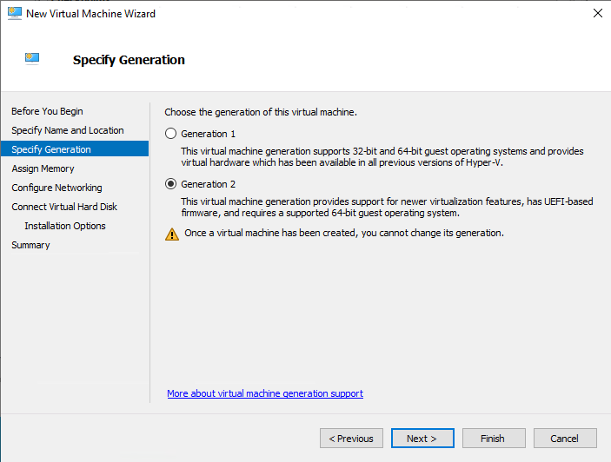

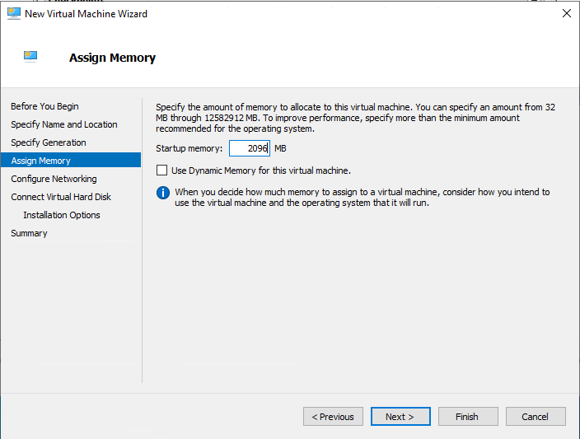

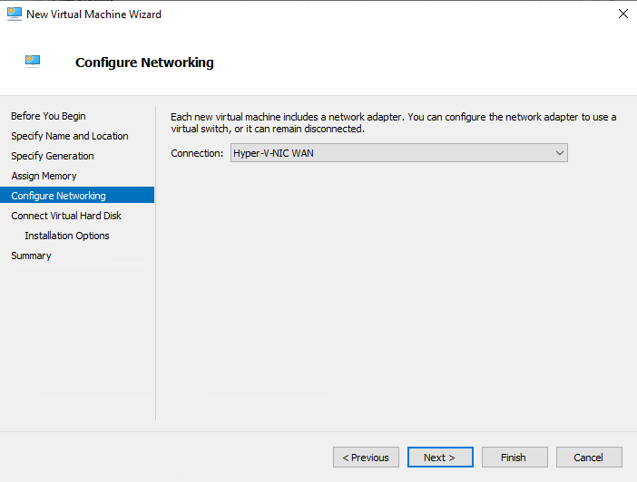

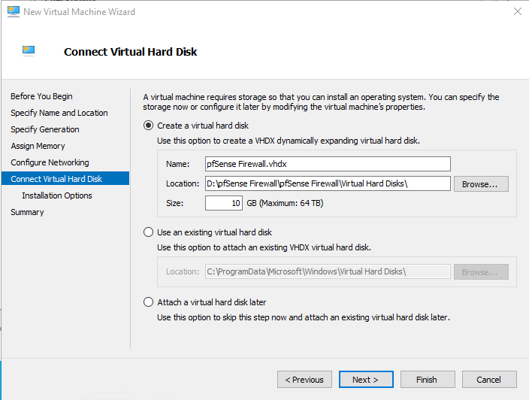

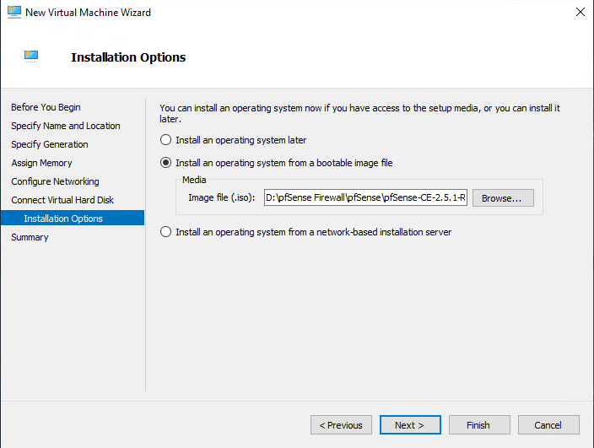

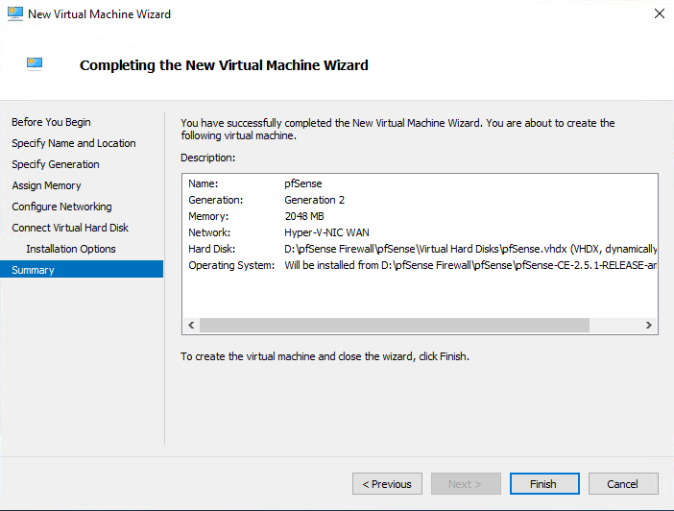

| Modify the virtual machine settings for pfSense |
| --- |

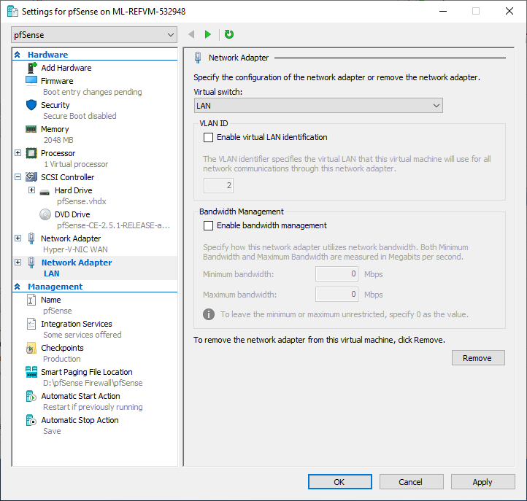

| Installation (Cont) |
| --- |

After successfully creating and configuring the pfSense software virtual machine, it’s time to start it.

* Select the VM in the Virtual Machines list in the Hyper-V Manager
* Click ‘**Start’** from the VM menu in the ‘**Actions** **panel’**
* Click ‘**Connect…**’ from the VM menu to open a console for the VM

Wait for the virtual machine to boot and launch the installer



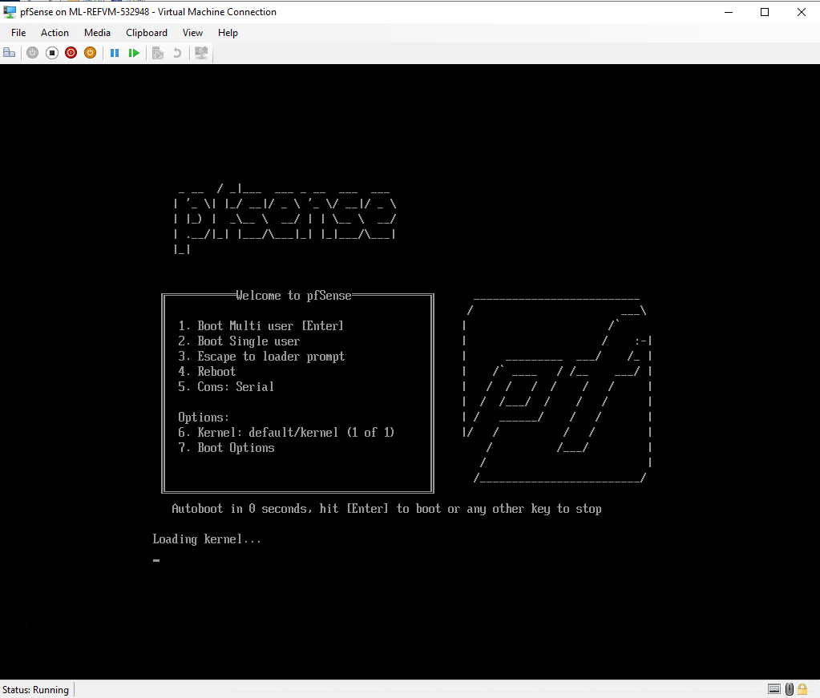



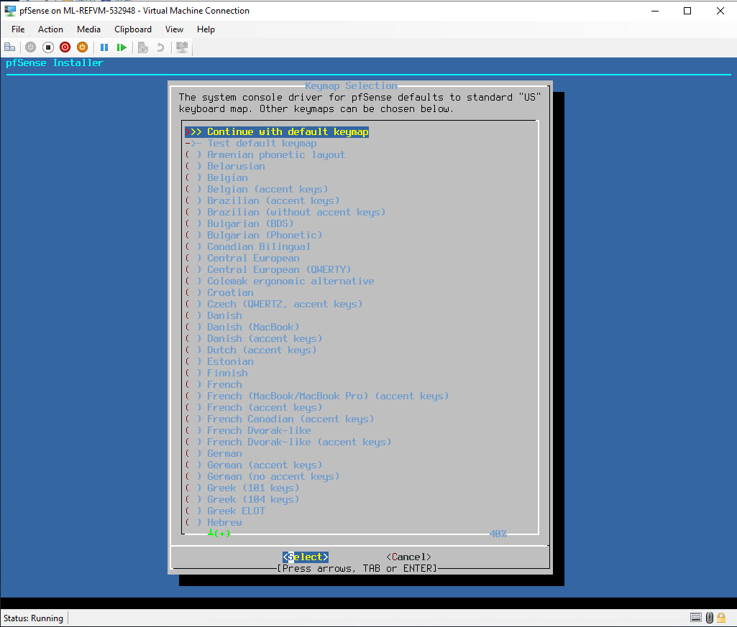



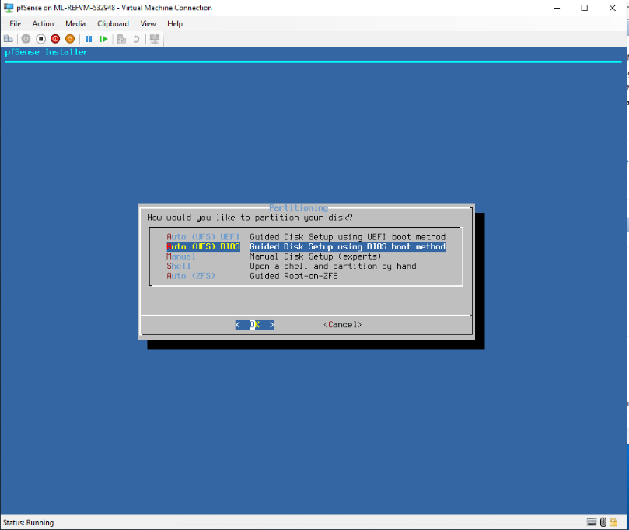



| Post Installation VM Configuration |
| --- |

Before pfSense is booted for the first time, there are some changes that must be made to the settings of the VM configuration.  
If pfSense was to be booted now, it would begin the installation process all over again, as the VM believes the boot image is still in the virtual drive and will boot from that image. Therefore, we must disable this.





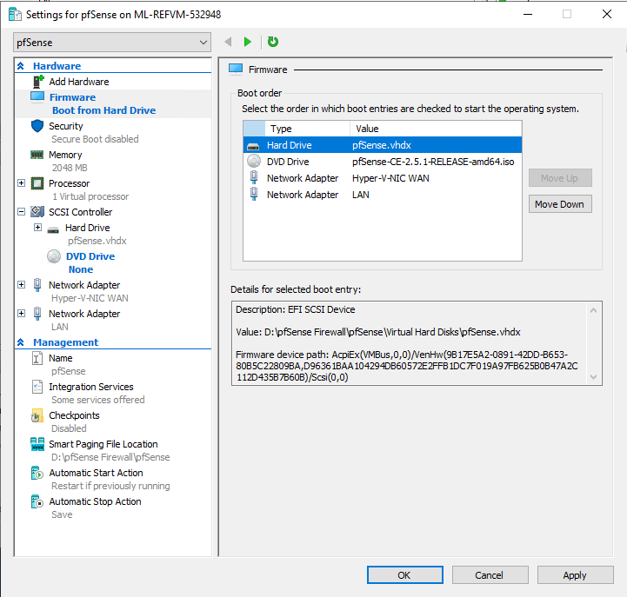

| First Boot and Configuration |
| --- |

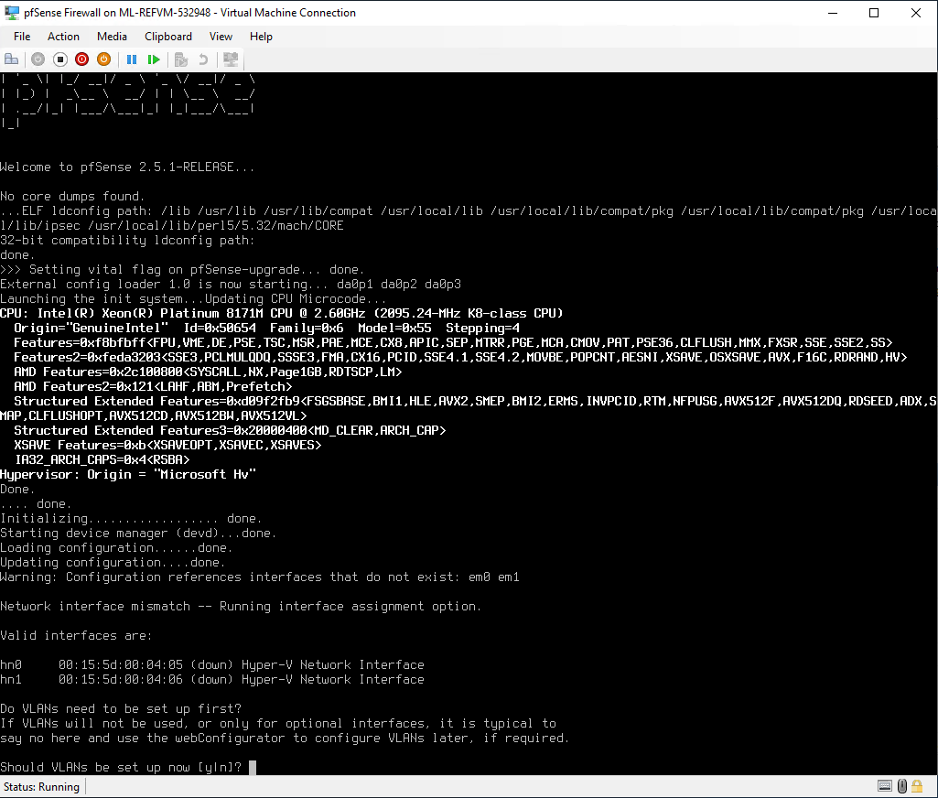







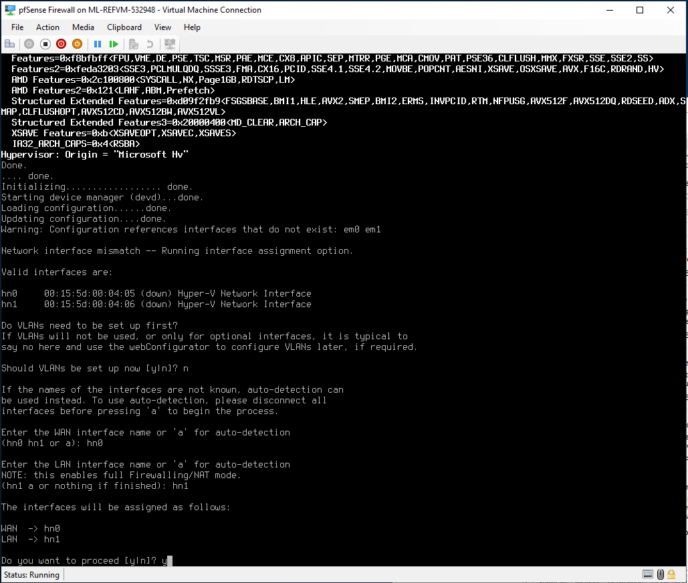

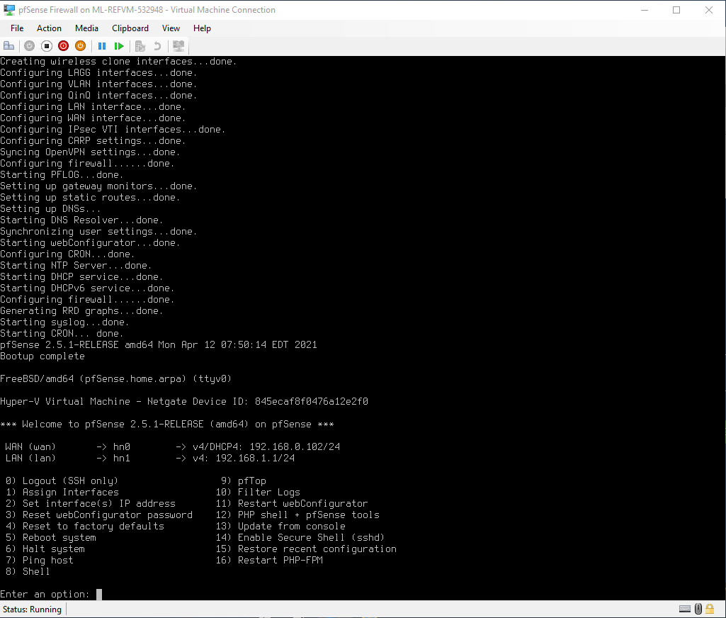

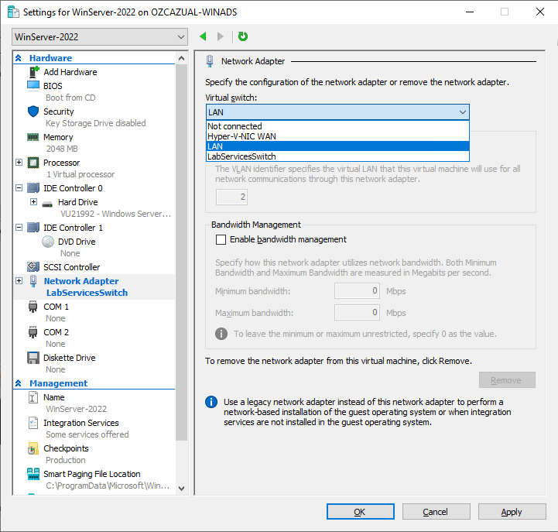

| Accessing the GUI |
| --- |





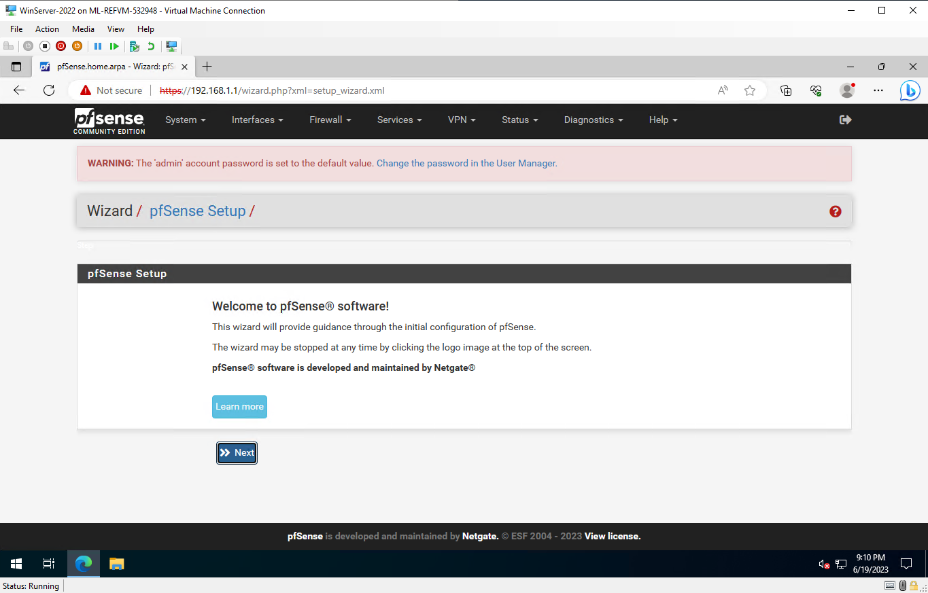

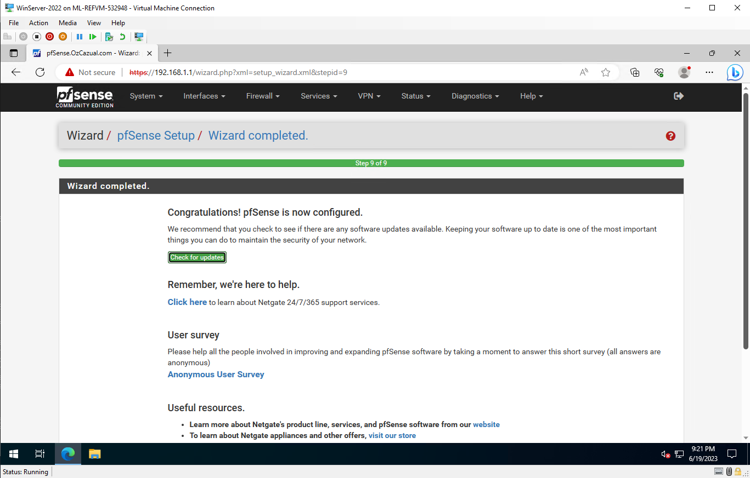



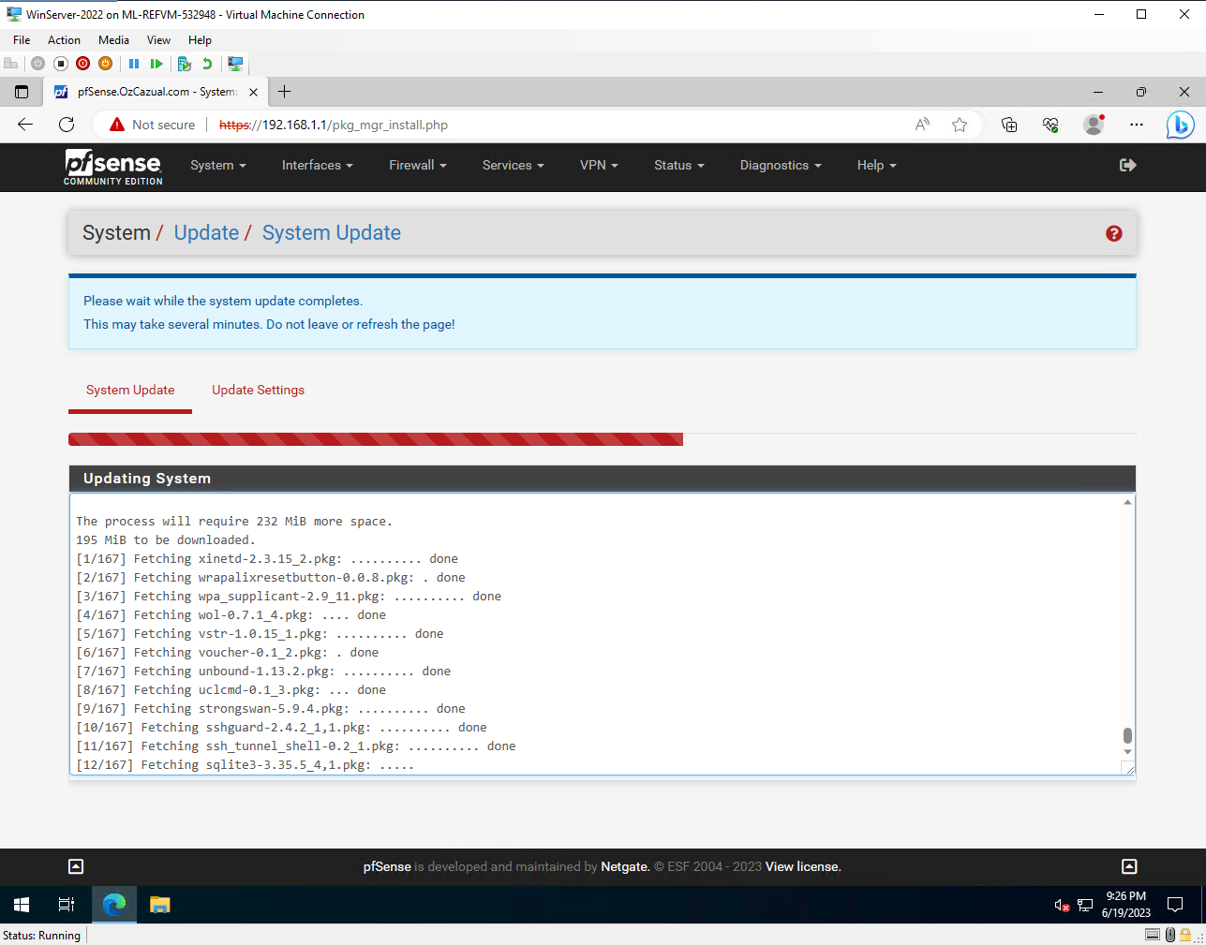

| User Management |
| --- |

| User Roles and Permissions |
| --- |

pfSense offers different user roles with varying levels of permissions, including:

* **Administrator:**  Full access to all pfSense features and configurations.
* **Power User:** Allows configuration changes but with some restrictions.
* **Read-only:**  Provides view-only access to monitor configurations and status.

User roles can be customised based on specific requirements and assigned to individual user accounts.

Using pfSense on a Windows 2022 AD Server allows for integration with Active Directory for user management.   
Here are the details regarding user management in pfSense:

| Creating and Managing User Accounts |
| --- |

User accounts in pfSense can be created and managed through the web interface.

To create a user account:

* Navigate to **System > User Manager** and click on the "**Add**" button.
* Enter the required information, including username, password, and email address.
* Additional options such as expiration date, descriptive name, and user certificate can also be configured.

| Defining and Assigning Roles and Capabilities |
| --- |

Roles define the permissions and capabilities assigned to user accounts.

To define roles:

* Go to **System** > **User Manager** > **Settings** and click on the "**Add**" button under "**User Management Settings**."
* Specify a name for the role and select the desired permissions and capabilities.

Once roles are defined, they can be assigned to user accounts by editing the user account and selecting the appropriate role.

| Authentication Options |
| --- |

pfSense supports various authentication options, including local authentication, LDAP (Lightweight Directory Access Protocol), and SSO (Single Sign-On).

| **Local Authentication:** | User accounts and passwords are stored locally on the pfSense system. |
| --- | --- |
| **LDAP Authentication:** | pfSense can authenticate users against an LDAP server, such as Active Directory, allowing centralized user management. |
| **SSO:** | Single Sign-On enables seamless authentication by leveraging an existing authentication mechanism, such as Active Directory credentials. |

C**onfiguring LDAP Authentication:**

Navigate to **System** > **User Manager** > **Authentication Servers** and click on the "**Add**" button.

Choose **LDAP** as the server type and provide the necessary configuration details, including the LDAP server's IP address, port, and authentication method.

Configure the Base DN (Distinguished Name) and Bind Credentials for the LDAP server.

Test the connection to ensure successful communication with the LDAP server.

Once configured, users can authenticate using their Active Directory credentials.

**Configuring SSO:**

pfSense supports SSO through integration with services like Microsoft Active Directory or RADIUS.

Detailed configuration steps may vary depending on the specific SSO implementation and integration requirements.

Consult the pfSense documentation or relevant guides for configuring SSO with your chosen authentication system.

By integrating with Active Directory, pfSense allows for centralized user management, role-based access control, and various authentication options. This integration simplifies user administration and enhances security by leveraging existing Active Directory infrastructure.

| Data Ingestion |
| --- |

When it comes to data ingestion in pfSense, the focus is primarily on logs and network data. Here are the details regarding data input options, configuring and managing data inputs, setting up source types, and managing data input pipelines:

| Data Input Options |
| --- |

| **Logs:** | pfSense can ingest logs generated by various network devices, servers, and applications. These logs can include firewall logs, DHCP logs, VPN logs, system logs, and more. |
| --- | --- |
| **Network Data:** | pfSense can capture network traffic data using packet capture tools like tcpdump or by enabling NetFlow or sFlow on network devices. This allows for the analysis of network flows, bandwidth usage, and traffic patterns. |
| **APIs:** | Some applications and systems may offer APIs that allow for direct data ingestion into pfSense. This can include pulling data from external sources, such as threat intelligence feeds or custom applications. |

| Configuring and Managing Data Inputs |
| --- |

| **Log Monitoring:** | pfSense can monitor log files on the local system or remote servers. Log files can be added and configured under the "Logs" section of the web interface. This allows for real-time log analysis and alerting. |
| --- | --- |
| **Network Port Monitoring:** | pfSense can listen on specific network ports to capture network traffic data. This is done by configuring packet capture rules under the "Diagnostics" section of the web interface. |
| **Scripted Inputs:** | Custom scripts can be written to fetch data from external sources and feed it into pfSense. These scripts can be scheduled to run at specific intervals and process data for ingestion. |

| Setting Up Source types and Automatic Field Extraction |
| --- |

| **Source types:** | In pfSense, source types help identify the source and format of the ingested data. Source Types can be assigned to different data inputs to distinguish between firewall logs, VPN logs, system logs, etc. |
| --- | --- |
| **Automatic Field Extraction:** | pfSense supports automatic field extraction, where it attempts to identify key fields within the ingested data. This process can be configured to extract fields based on predefined patterns, regular expressions, or specific log formats. |

| Managing Data Input Pipelines and Source types |
| --- |

| **Data Input Pipelines:** | In pfSense, data inputs are processed by the underlying log management system, such as the ELK (Elasticsearch, Logstash, Kibana) stack. The log management system handles the indexing, storage, and search functionalities of the ingested data. |
| --- | --- |
| **Source type Management:** | pfSense allows for the management of source types, including adding new source types, modifying existing ones, or mapping source types to specific data inputs. This helps in organising and categorising the ingested data for easier analysis and searching. |

pfSense itself provides some data ingestion capabilities, more advanced data collection and analysis can be achieved by integrating pfSense with external log management or SIEM (Security Information and Event Management) solutions, such as ELK stack, Splunk, or Graylog.

These external systems offer advanced data ingestion, processing, and visualisation capabilities for comprehensive network monitoring and security analysis.

| Search and Analysis |
| --- |
| When it comes to search and analysis in pfSense, the focus is primarily on log data.  Here are details regarding basic and advanced search techniques, search operators and commands, building search queries, filtering results, and transforming and visualizing data:  **Basic and Advanced Search Techniques**   * **Basic Search:** pfSense provides a search interface where you can enter keywords or phrases to search for specific events or log entries. This allows you to quickly find relevant information based on specific criteria. * **Advanced Search:** In addition to basic keyword searches, pfSense supports advanced search techniques that enable more precise and complex searches. These techniques include using search operators, commands, and functions.   **Search Operators, Commands, and Functions**   * **Search Operators:** pfSense supports search operators such as AND, OR, NOT, and parentheses for combining search terms and creating more complex search conditions. * **Commands:** pfSense provides various search commands that allow you to perform specific actions or calculations on the search results. For example, you can use the stats command to calculate statistics, or the sort command to order the search results. * **Functions:** pfSense supports functions that allow you to manipulate and transform the search results. Functions can be used to extract specific fields, perform calculations, apply regular expressions, and more.   **Building Search Queries and Filtering Results**   * **Building Queries:** pfSense allows you to build search queries by combining search terms, operators, commands, and functions. You can specify search criteria based on specific fields, time ranges, or other relevant attributes. * **Filtering Results:** pfSense provides various options for filtering search results. You can filter results based on time ranges, specific field values, or other conditions to narrow down the data and focus on the information that is most relevant to your analysis.   **Transforming and Visualizing Data**   * **Transforming Data:** pfSense allows you to transform the search results using commands and functions to manipulate, aggregate, or summarize the data. For example, you can calculate totals, averages, or percentiles using statistical functions or apply data manipulation functions to reformat the results. * **Visualizing Data:** pfSense offers visualization capabilities that allow you to create charts, tables, and time series graphs based on the search results. Visualizations can provide a visual representation of the data, making it easier to identify trends, patterns, or anomalies.   Specific search and analysis capabilities in pfSense may vary depending on the log management or SIEM solution integrated with pfSense. External log management solutions like the ELK stack, Splunk, or Graylog provide advanced search functionalities, powerful query languages, and comprehensive visualization options for in-depth analysis of log data. |

| Data Management |
| --- |
| When it comes to data management in pfSense, the focus is primarily on log data and the underlying log management system, such as the ELK (Elasticsearch, Logstash, Kibana) stack.  **Indexing Configuration and Best Practices**   * **Indexing Configuration:** pfSense leverages the capabilities of the underlying log management system for indexing configuration. This includes defining index settings such as the number of shards, replicas, and index mapping.   **Best Practices:** Ensure proper sizing of indexes based on expected data volume and retention requirements.   * Follow recommended index naming conventions for easier management and searching. * Configure appropriate index settings for optimal performance and resource utilization. * Regularly monitor and optimize index settings based on the evolving data requirements.   **Managing Indexes**   * **Index Creation:** Indexes are typically created automatically by the underlying log management system based on predefined configurations. This includes index creation based on time intervals (e.g., daily or monthly) or other criteria. * **Index Deletion:** pfSense allows for the deletion of indexes that are no longer needed or have reached the end of their retention period. This helps manage disk space and improves performance by reducing the amount of data to search and analyze. * **Retention Policies:** Configuring retention policies ensures that data is retained for the desired duration based on compliance requirements, operational needs, or data analysis purposes. Retention policies define how long data should be kept before it is deleted or moved to long-term storage.   **Data Lifecycle Management**   * **Archiving:** Archiving involves moving data from active indexes to long-term storage for historical purposes or compliance requirements. Archived data can be stored in separate storage systems or offline media. * **Freezing:** Freezing allows you to make certain data read-only, preventing any modifications or deletions. This is useful for preserving data integrity and ensuring data is securely stored for compliance or legal purposes. * **Summarization:** Summarization involves aggregating and summarizing large volumes of data to reduce storage requirements and facilitate faster analysis. Summarized data can be stored separately or used for generating reports, dashboards, or visualizations.   **Working with Summary Indexes and Accelerated Data Models**   * **Summary Indexes:** Summary indexes store pre-aggregated or summarized data for faster querying and analysis. They are created based on specific search criteria or statistical functions applied to raw data. Summary indexes allow for quicker retrieval of commonly accessed or aggregated information. * **Accelerated Data Models:** Accelerated data models are pre-built data structures that optimize the querying and analysis of specific types of data. They provide pre-calculated fields, data relationships, and other optimizations for faster search performance.   While pfSense itself provides some data management capabilities, more advanced data management, indexing, and optimization features can be achieved by integrating pfSense with external log management or SIEM solutions like the ELK stack, Splunk, or Graylog.  These solutions offer robust data management functionalities, including advanced indexing, data lifecycle management, and accelerated data modelling for efficient log analysis and reporting. |

| Security and Access Control |
| --- |
| When it comes to security and access control in a program deployment like pfSense, several measures can be implemented to ensure a secure environment. These are some practices for securing program deployments, user authentication and authorization, role-based access control (RBAC), and implementing SSL/TLS encryption for data in transit:  **Securing Program Deployments**   * **Firewalls:** pfSense itself acts as a firewall and provides robust network security features. Ensure that the firewall rules are properly configured to allow only necessary network traffic and block unauthorized access. * **Network Restrictions:** Implement network restrictions such as VLANs (Virtual Local Area Networks) and subnet segregation to separate and secure different network segments. Apply access controls to restrict communication between segments based on the principle of least privilege.   **User Authentication and Authorization**   * **Local Authentication:** pfSense supports local authentication, allowing users to authenticate directly against the pfSense system using locally defined user accounts and passwords. * **LDAP Authentication:** pfSense can integrate with an LDAP server, such as Microsoft Active Directory, for user authentication. This enables centralized user management and leverages existing user accounts and credentials. * **SSO (Single Sign-On):** Implementing SSO allows users to authenticate once and gain access to multiple systems and applications. pfSense can integrate with SSO solutions like Active Directory Federation Services (ADFS) or SAML (Security Assertion Markup Language) for seamless authentication.   **Role-Based Access Control (RBAC) and Permissions**   * **RBAC:** pfSense offers role-based access control, allowing the assignment of different roles to users or groups. Each role has specific permissions and privileges associated with it, enabling fine-grained control over access to pfSense features and configurations. * **Permissions:** Define and customize permissions within pfSense based on specific roles or user requirements. Granular permissions allow for precise control over the actions and configurations that users can perform within the system.   **Implementing SSL/TLS Encryption for Data in Transit**   * **SSL/TLS Certificates:** Generate or obtain SSL/TLS certificates for pfSense to enable secure communication over HTTPS. Certificates ensure encrypted communication between clients and the pfSense web interface, protecting sensitive data in transit. * **Certificate Management:** Manage SSL/TLS certificates within pfSense, including importing, renewing, and revoking certificates. Regularly update and replace certificates to maintain the security of data in transit. * **HTTPS Configuration:** Configure pfSense to enforce HTTPS connections by redirecting HTTP traffic to HTTPS. This ensures that all communication with the pfSense web interface is encrypted.   By implementing these security and access control measures, you can enhance the overall security posture of your pfSense deployment. It is crucial to regularly review and update security configurations to address emerging threats and maintain a secure environment.  Additionally, following security best practices, such as applying system updates, monitoring logs for suspicious activities, and implementing intrusion detection and prevention systems, can further bolster the security of your pfSense deployment. |

| Monitoring and Troubleshooting |
| --- |
| Monitoring and troubleshooting are essential aspects of maintaining a program deployment like pfSense.  **Monitoring Program Performance and Resource Usage**   * **System Health Monitoring:** Utilize monitoring tools or built-in monitoring features to track the health of the pfSense system. Monitor system metrics such as CPU usage, memory utilization, disk I/O, and network traffic to identify any performance bottlenecks or resource limitations. * **Indexing Throughput Monitoring:** Monitor the indexing throughput to ensure efficient processing of logs and events. Keep an eye on indexing rates, queue sizes, and any backpressure in the indexing pipeline to identify potential performance issues.   **Troubleshooting Common Issues and Error Messages**   * **Error Message Analysis:** When encountering error messages or warnings, refer to documentation or online resources specific to pfSense. Error messages often provide valuable insights into the root cause of issues and can guide troubleshooting steps. * **Knowledge Base and Forums:** Leverage the pfSense community knowledge base and online forums to search for solutions to common issues. Participate in discussions and seek assistance from experienced users or support teams.   **Debugging and Analyzing Search Performance**   * **Search Performance Analysis:** Monitor search performance metrics such as search execution time, resource consumption, and search response times. Identify any slow-performing searches and investigate potential causes, such as complex search queries, inefficient search commands, or data volume. * **Debugging Tools:** Utilize debugging tools provided by pfSense or the underlying log management system to analyze and debug search performance issues. These tools may include search profiling, search job inspection, or search command optimization techniques.   **Logging and Monitoring Program Components**   * **Log Analysis:** Regularly review logs generated by pfSense components such as the indexer, search head, or forwarder. Logs provide insights into system activities, errors, warnings, and performance-related information. Analyze logs to identify potential issues or abnormal behaviors. * **Monitoring Solutions:** Deploy monitoring solutions or use built-in monitoring features to track the health and performance of pfSense components. This may involve monitoring system metrics, log data, and component-specific metrics to ensure smooth operation and timely detection of any issues.   It is recommended to establish proactive monitoring practices, set up alerting mechanisms for critical events or performance thresholds, and maintain a log management strategy that includes regular log rotation and archiving.  Additionally, staying updated with pfSense community resources, documentation, and release notes can provide valuable insights into troubleshooting techniques and best practices specific to the version and deployment of pfSense. |

| Maintenance and Upgrades |
| --- |
| **Routine Maintenance Tasks**   * **Log Rotation:** Implement a log rotation strategy to manage log file sizes and prevent them from consuming excessive disk space. Regularly rotate logs based on predefined intervals or size limits to ensure efficient log management. * **Data Grooming:** Implement data grooming practices to remove or archive old or unnecessary data. This helps optimize storage space and improve system performance. Define retention policies and regularly review data to determine which information can be safely removed or archived.   **Applying Updates and Patches to the Program**   * **Update Notification:** Stay informed about pfSense updates and patches. Subscribe to relevant mailing lists, forums, or vendor notifications to receive updates regarding new releases, security patches, and bug fixes. * **Update Planning:** Before applying updates, review release notes and documentation to understand the changes, enhancements, and potential impact on your environment. Plan updates during maintenance windows to minimize disruptions and ensure proper testing and rollback procedures are in place. * **Update Process:** Follow the recommended update process provided by pfSense. This may involve downloading the latest update, verifying its integrity, and applying it to the system. Ensure that all dependencies and prerequisites are met before initiating the update process.   **Backup and Disaster Recovery Procedures**   * **Backup Strategy:** Develop a comprehensive backup strategy that includes regular backups of critical system configurations, log data, and any additional data sources or settings. Determine the appropriate backup frequency and retention period based on your operational requirements and compliance policies. * **Disaster Recovery Plan:** Create a disaster recovery plan that outlines the steps to recover the pfSense system in the event of a catastrophic failure or data loss. This plan should include procedures for restoring backups, rebuilding the system, and ensuring business continuity.   **Version Compatibility Considerations and Upgrade Planning**   * **Compatibility Testing:** Before upgrading pfSense, assess the compatibility of your existing configurations, add-ons, and third-party integrations with the target version. Test the new version in a non-production environment to ensure that all critical functionalities work as expected. * **Upgrade Planning:** Plan upgrades carefully, considering the potential impact on system configurations, hardware requirements, and any customizations or modifications made to the existing environment. Follow upgrade guides and documentation provided by pfSense to ensure a smooth and successful upgrade process.   Regularly review pfSense documentation, user forums, and official resources to stay up to date with best practices, maintenance recommendations, and upgrade guidelines specific to the version and deployment of pfSense. It is crucial to allocate dedicated time for maintenance activities and prioritize the application of security patches and updates to keep the system secure and running efficiently. |

| Best Practices |
| --- |
| **Performance Optimization Tips**   * **Indexing Volume:** Optimise indexing volume by ensuring that only relevant data is being ingested and indexed. Consider filtering out unnecessary logs or events to reduce the volume of data being processed and improve indexing performance. * **Search Efficiency:** Write efficient search queries by leveraging search optimization techniques such as using specific time ranges, utilising appropriate search operators, and utilizing field constraints to narrow down search scopes. Avoid unnecessary data retrieval and processing to improve search performance.   **Data Onboarding and Normalization Best Practices**   * **Standardize Data Formats:** Normalize incoming log data by applying consistent formats across different sources. This ensures easier data parsing, analysis, and correlation. Consider using common log formats like JSON or syslog whenever possible. * **Use Parsing and Field Extraction:** Configure parsing and field extraction mechanisms to extract relevant information from raw log data. Properly defined sourcetypes and regular expression patterns can help automate the parsing process and ensure consistent field extraction. * **Validate and Cleanse Data:** Implement data validation and cleansing processes to identify and remove any anomalies or inconsistencies in the data. This ensures data integrity and accurate analysis results.   **Security and Compliance Recommendations**   * **Audit Logs:** Enable comprehensive logging and auditing capabilities within pfSense to track system activities, user actions, and configuration changes. Regularly review audit logs to detect any suspicious activities or potential security breaches. * **Access Controls:** Implement granular access controls and role-based permissions to restrict system access to authorized personnel. Ensure that each user has appropriate privileges based on their roles and responsibilities. * **Compliance Frameworks:** Align your pfSense deployment with relevant compliance frameworks such as PCI DSS, HIPAA, or GDPR, if applicable. Follow recommended security controls, data protection measures, and reporting requirements to maintain compliance.   **Scaling and Capacity Planning Guidelines**   * **Scalability:** Design your pfSense deployment with scalability in mind to accommodate future growth. Consider the expected volume of data, user concurrency, and system requirements when determining hardware resources and sizing. * **Distributed Deployment:** If needed, distribute the load across multiple pfSense instances or deploy a clustered setup for high availability and improved performance. Load balancing and distributed architecture can help handle increased traffic and ensure system resilience. * **Regular Monitoring and Capacity Assessment:** Continuously monitor system performance, resource utilization, and data growth trends. Conduct regular capacity assessments to identify potential bottlenecks or resource limitations and plan for scaling resources accordingly.   Adhering to these best practices can help optimize the performance, security, and scalability of your pfSense deployment. It's important to regularly review and update your configurations, stay informed about emerging security threats and best practices, and leverage the resources and community support available for pfSense to ensure a robust and efficient deployment. |

| Resources and References |
| --- |
| **Documentation Links:**   * **Official pfSense Documentation:**  The official documentation for pfSense can be found on the pfSense website. It provides comprehensive information about installation, configuration, troubleshooting, and advanced topics.  Visit: <https://docs.netgate.com/pfsense/en/latest/> * **Release Notes:**  Stay updated with the latest features, bug fixes, and improvements by referring to the release notes specific to each pfSense version. These can be found in the documentation section or on the pfSense website.   **Community Forums and Support Resources:**   * **pfSense Forum:**  The pfSense community forum is an active platform where users and experts share their experiences, ask questions, and provide support. It is a great place to seek advice, find solutions to common issues, and stay updated with the latest developments.  Visit: <https://forum.netgate.com/> * **Reddit:**  The pfSense subreddit (/r/pfSense) is another community-driven platform where users discuss pfSense-related topics, share tips and tricks, and seek assistance.  Visit: <https://www.reddit.com/r/PFSENSE/>   **Training and Certification Options:**   * **pfSense Training:**  Netgate, the company behind pfSense, offers official training courses covering various aspects of pfSense deployment, configuration, and administration. These courses provide in-depth knowledge and practical hands-on experience.  Visit: <https://www.netgate.com/training/> * **pfSense Certification:**  Netgate also offers pfSense certification programs, allowing individuals to validate their pfSense knowledge and skills. Certification exams are available for different levels, such as Associate and Professional.  Visit: <https://www.netgate.com/certification/>   **Additional References:**   * **Blogs and Webinars:**  Many pfSense enthusiasts and experts maintain blogs and host webinars where they share insights, best practices, and real-world use cases. Examples include Lawrence Systems (YouTube channel and blog) and Netgate's official blog. These resources can provide additional guidance and practical tips. * **Whitepapers and Case Studies:**  Netgate provides whitepapers and case studies that cover various topics related to pfSense deployment, security, and performance optimization. These resources offer in-depth analysis and guidance for specific scenarios and use cases.   These resources mentioned above should be regularly checked, as they are regularly updated and maintained by the pfSense development team. Additionally, engaging with the pfSense community through forums and attending training courses can provide valuable insights and support for your pfSense deployment. |